

Gary Herbert Endorses Background Checks for BB Guns!
Gun control commando and former New York mayor Michael Bloomberg (co-founder of “Mayors Against Illegal Guns” and similar enterprises) enjoys plenty of support amongst Utah’s wanna-bee elitists. Consider Utah’s Executive Monarch (i.e. “governor”) Gary Herbert:

“I believe that we ought to have background checks to keep guns, no matter what caliber, it could be a BB gun, out of the hands of criminals and those who are mentally unstable, and that ought to happen when we purchase a gun upfront, and it’s hard to regulate that because we have private purchases that nobody knows about; it’s hard to do background checks on, and unless we come up with a better system than we’ve got now, there are going to be people who slip through the cracks." [bold added] — Gary Herbert on the Rod Arquette Show, April 22, 2013. Listen to this clip at http://utgunrights.com/freeammo/bloombergs-busy-bees.htm#herbert-bb-guns

Visit UTGunRights.com to see how Herbert and your house and senate statutators rated in the 2016 Utah Government Corruption Report.

Sign up for free email alerts at info@utgunrights.com, and “Like” UT Gun Rights on Facebook at https://www.facebook.com/UtGunRights
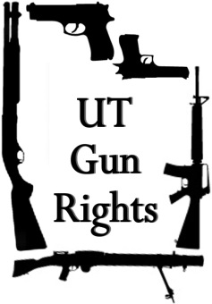
UT Gun Rights promotes the right of individuals to keep and bear firearms, responsible and confident firearms ownership and use, and political accountability at the state and local level.

It is your natural right to defend yourself from unjust attacks by any individual, mob, or government. This is self-evident to all but the naïve — and the corrupt politicians and institutions that manipulate them.

Copyright © 2016 by UT Gun Rights. Public reproduction and dissemination of this flier is hereby authorized.

